

DEPARTMENT OF COMPUTER SCIENCE AND ENGINEERING

Course Code: CSE491
Name: Nazmus Saquib
ID: 17101469
Email: nazmus.saquib@g.bracu.ac.bd
Project Title: Podcast Mobile Application
Download link and live online link (for web projects):

Project Features:

The implemented features are explain with screenshots below :

a) Welcome screen :

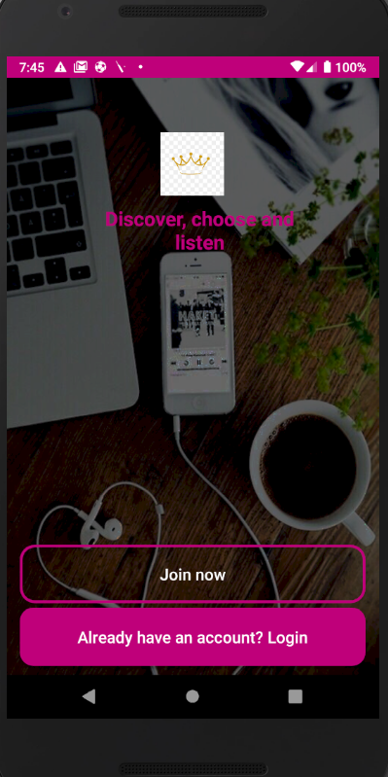
b) Create account screen :
Only users can create account. Data get stored in firebase. Admins can not create account dynamically.

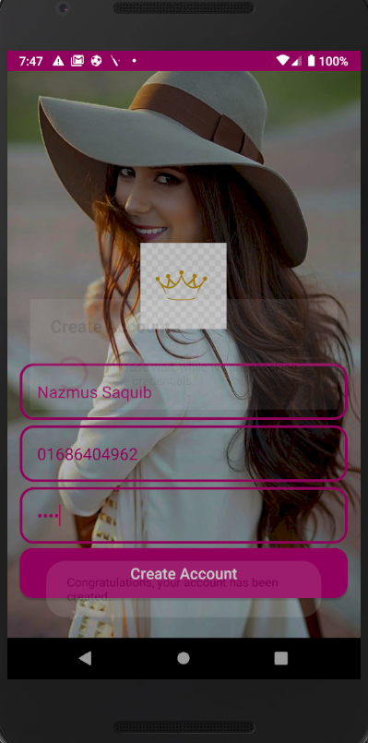

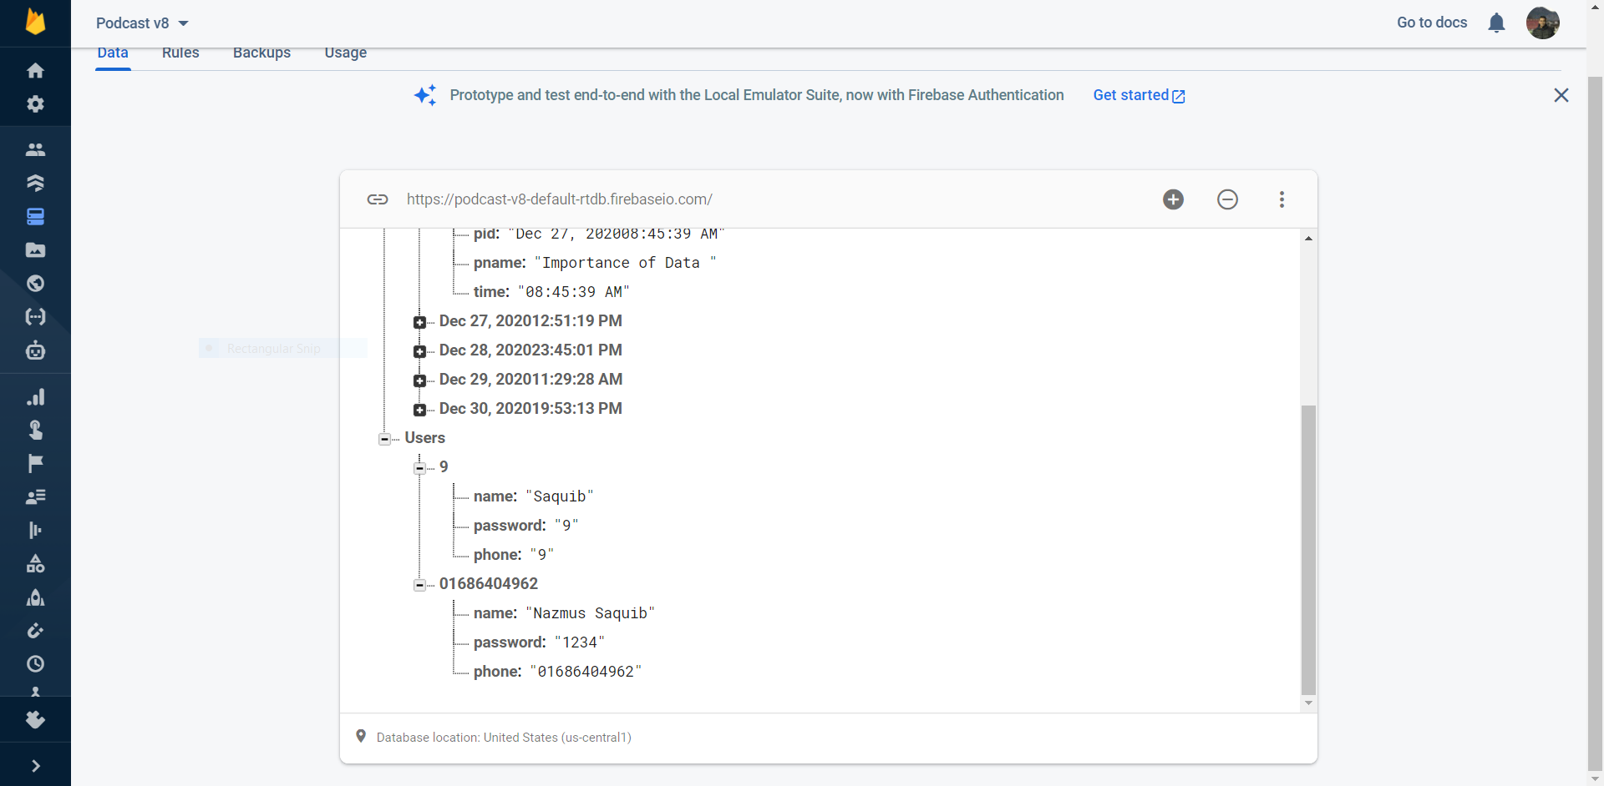

c) Admin log in screen :

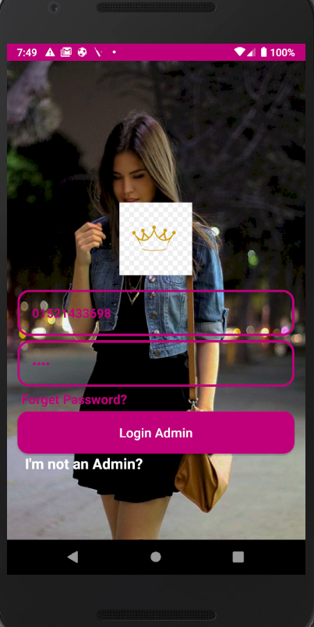

d) Admin home screen :
Shows categories to upload podcasts in. There is a log out button too.

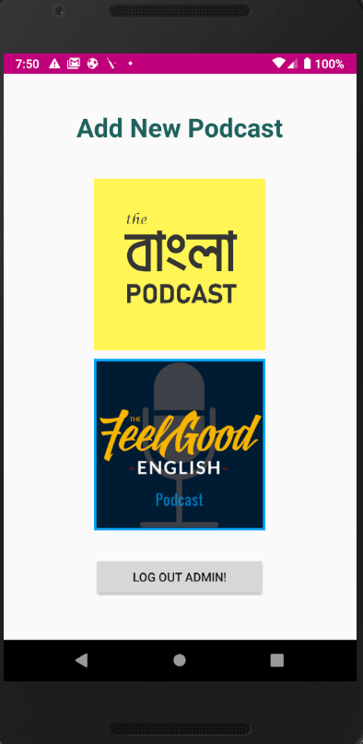

e) Admin upload podcast screen :

Admin can upload an audio file, podcast name and details.
These data get stored in Firebase.

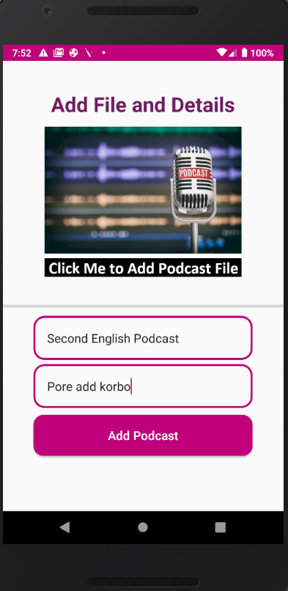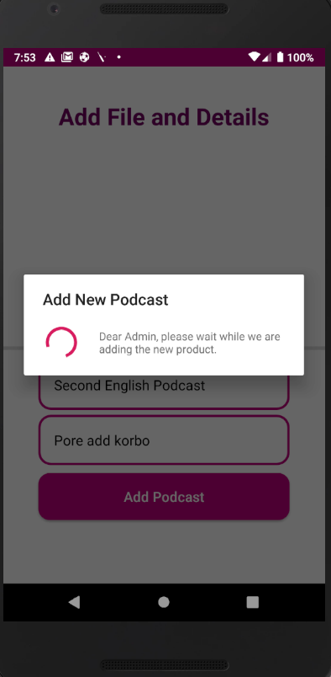

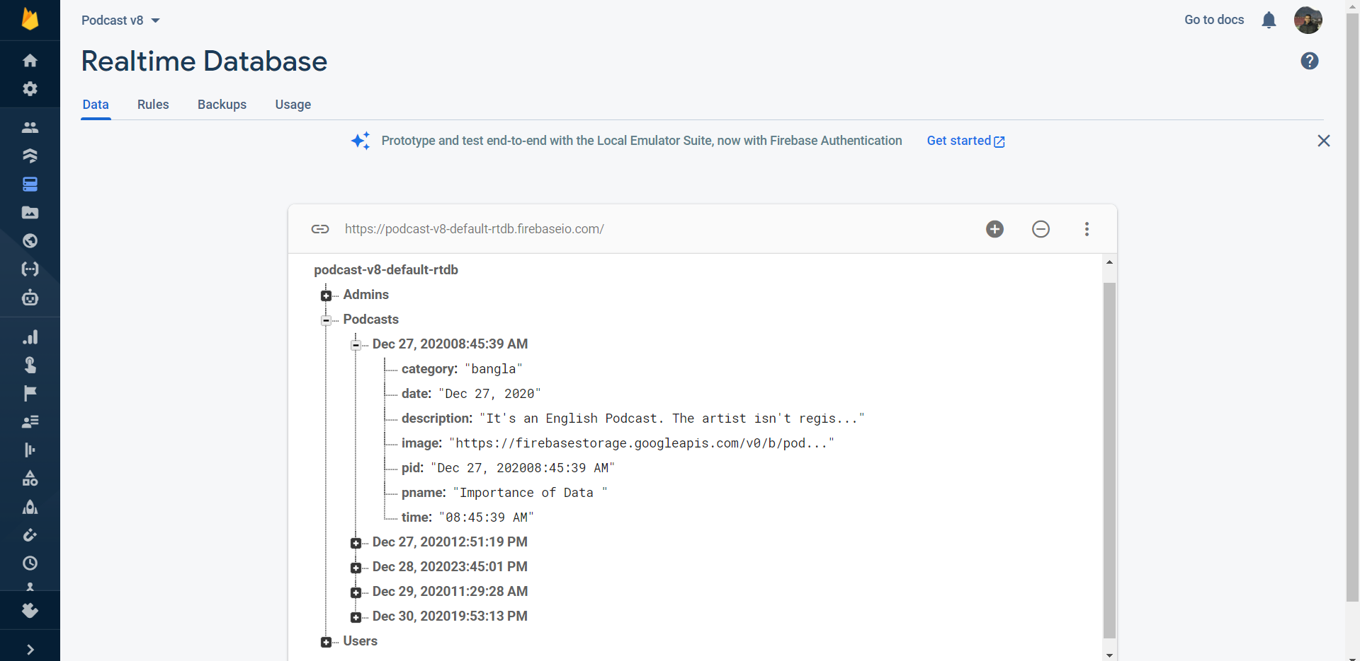

f) User sign in screen :
Sign in data gets validated from our firebase database that we have shown in (b).

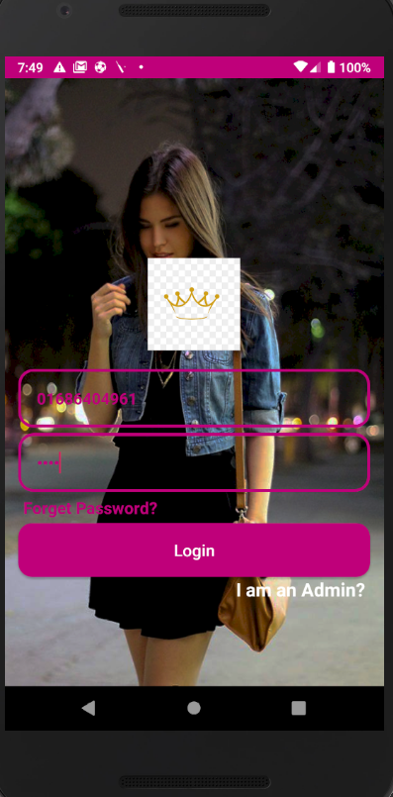

g) User home screen :

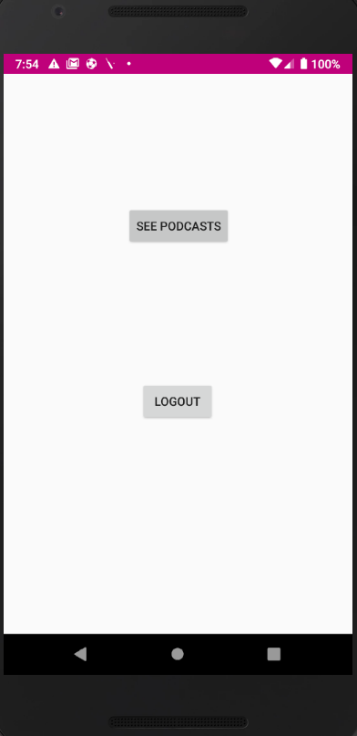

h) Home screen > See Podcasts :
Here user can chose category to listen podcast from.

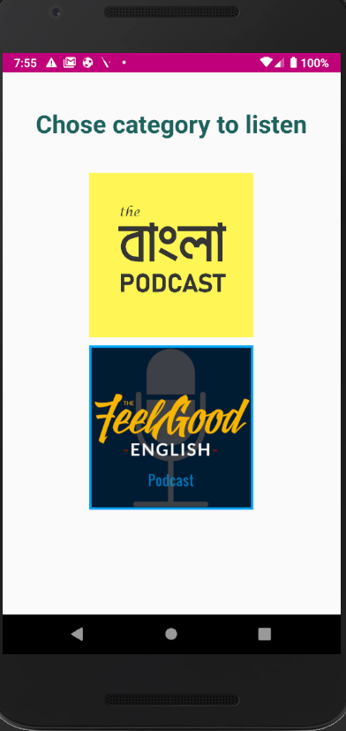

i) Podcast list in the chosen category : The data are brought straight from the firebase database.

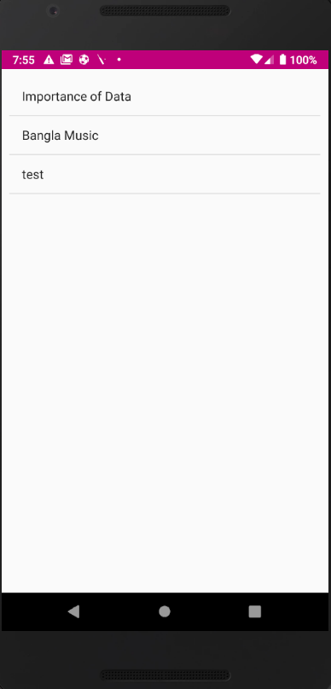

j) Podcast player :

If we press any of the item from the list, it starts to play. The music are imported from firebase url that are stored in the firebase database.

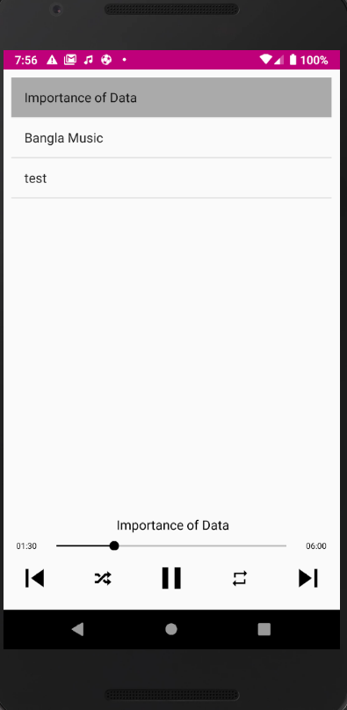

k) Play podcast in Background :

The podcasts also play in the background of the app.

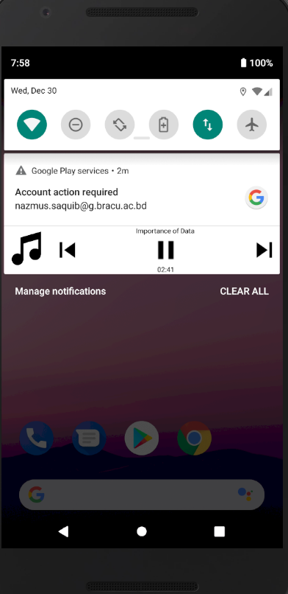

Online Resources used:

a) Reference:
- Firebase website

- Android documentation website

- Youtube videos:

https://www.youtube.com/watch?v=6keVIot98QU&list=PLxefhmF0pcPlqmH_VfWneUjfuqhreUz-O&index=1

b) Stackoverflow / github links :

https://github.com/jeancsanchez/JcPlayer

https://github.com/arsltech/FirebaseMusicPlayer

https://stackoverflow.com/questions/51406414/getting-a-specific-category-of-data-from-firebase

Future Enhancements:

Following enhancement can be added to the current system which will improve the system.
- Admin can not create categories dynamically. We will implement it in the fitire.

- Add to favourites option can be implemented.

